**Journey Through Candyland**

Journey through candyland is a hard-core side scrolling adventure where the player tries to make their way to the tough world that is candyland, the player is forced to dodge the enemies and try and get the candy, all in a futile effort to stay alive.

The game has a constant speed that everything moves at and if the player goes too far off to the side they die… If the player hits an enemy they lose a life… if they lose too many lifes they die… That’s pretty much it.

Features:

* High score list that is saved on close
* Difficulty that changes and changes on the screen
* Infinite scroll, as long as the player has health
* Allows user to create a name and shows it at the top of the game whilst it’s running.

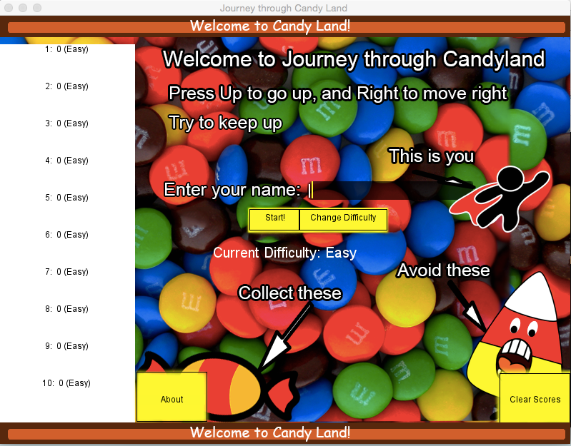

The user can enter their own name

The difficulty can be changed and will be updated here

The high scores, buttons and most text is handled by the panel

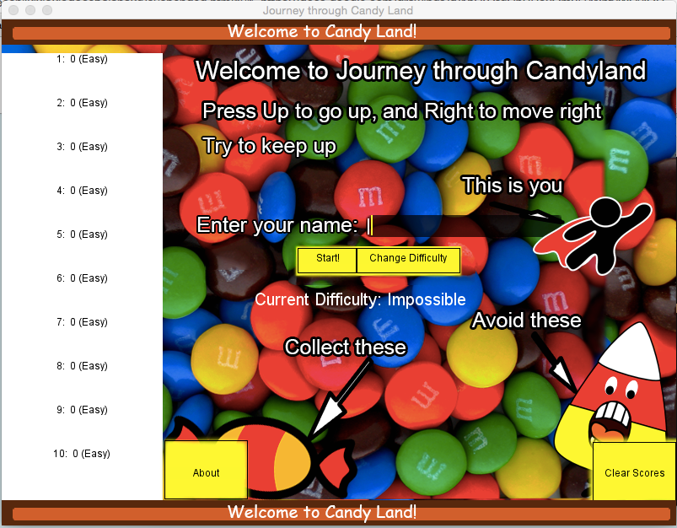

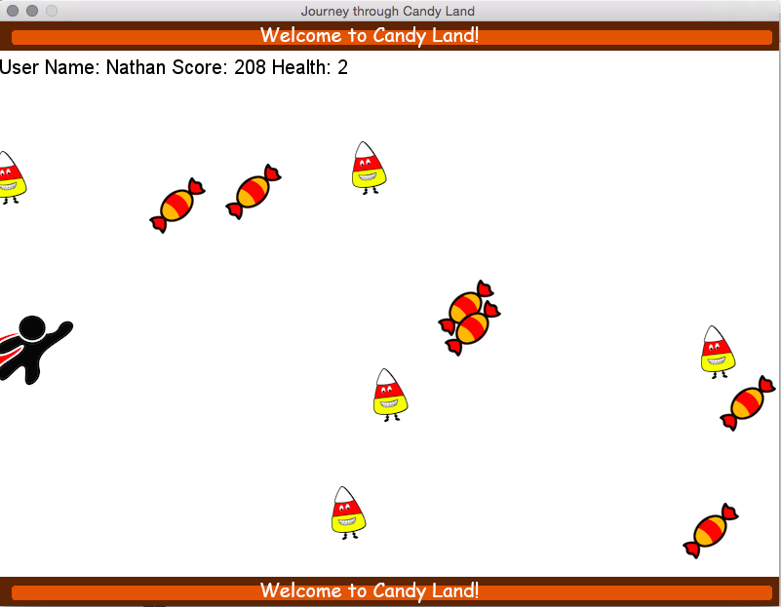

The top shows the username, current score and health  
  
The user needs to collect the candy, but at the same time avoid the candycorn

<https://docs.google.com/drawings/d/1hU07tqChBRoxOm05yWnfvWCvIOHTwEigkAqOMx0M30A/edit?usp=sharing>

